By Sumathi Reddy
Nov. 26, 2018 11:00 a.m. ET
Bronx, N.Y.
Otis is squealing with joy as he swings, lying belly-down in a blue net swing, trying to reach the ladder before him. The 7-year-old’s goal: to pull himself up a few rungs and grab a bean bag from the bucket dangling enticingly above him.
This isn’t gymnastics class or a playground—it’s a therapy session. Otis is part of a study at Albert Einstein College of Medicine/Montefiore Health System where researchers are testing two autism therapies and how they affect the brain.
“The bean bags are all the way up there. How are you going to go up there?” Tim Conly, a senior occupational therapist at Montefiore, asks Otis.
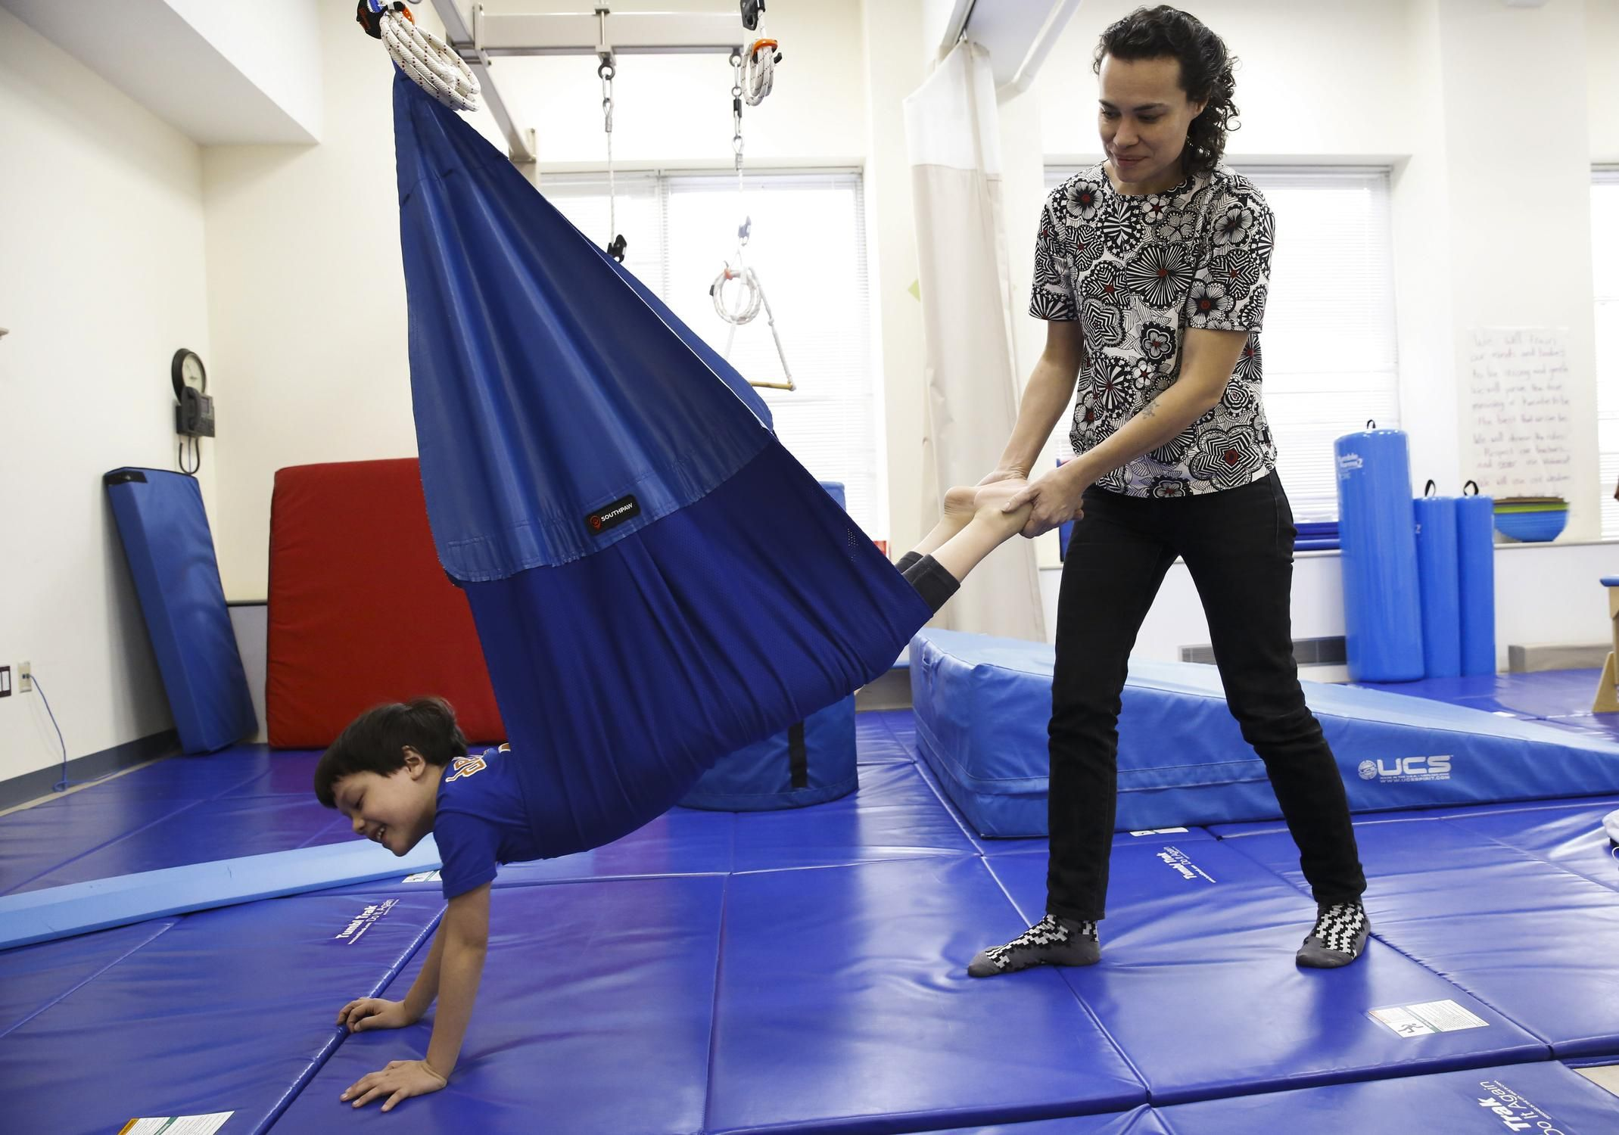
Otis was randomly placed in the group of children who receive sensory integration therapy. Here his mother helps push him in a swing during a therapy session.
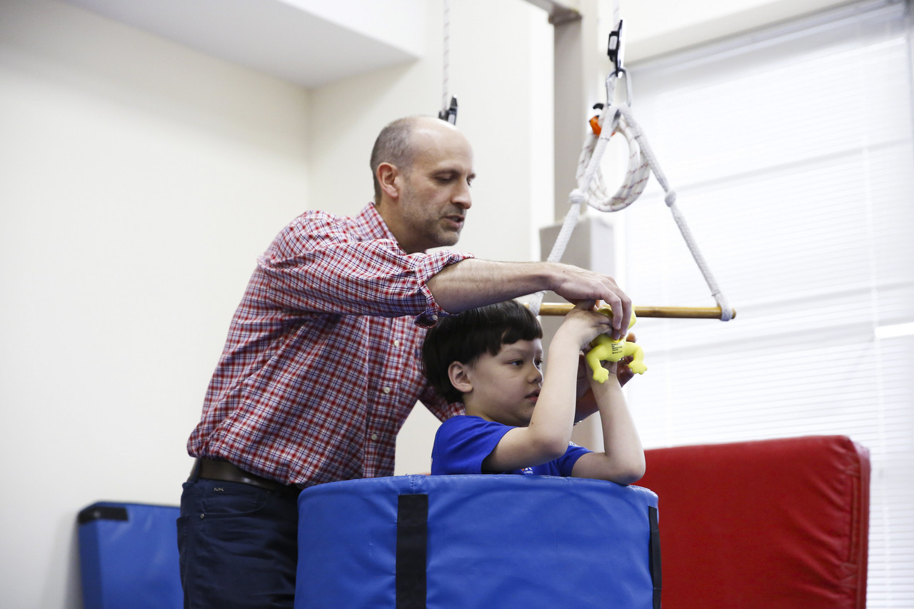
Tim Conly, an occupational therapist, helps Otis aim bean bags at a row of plastic cups.
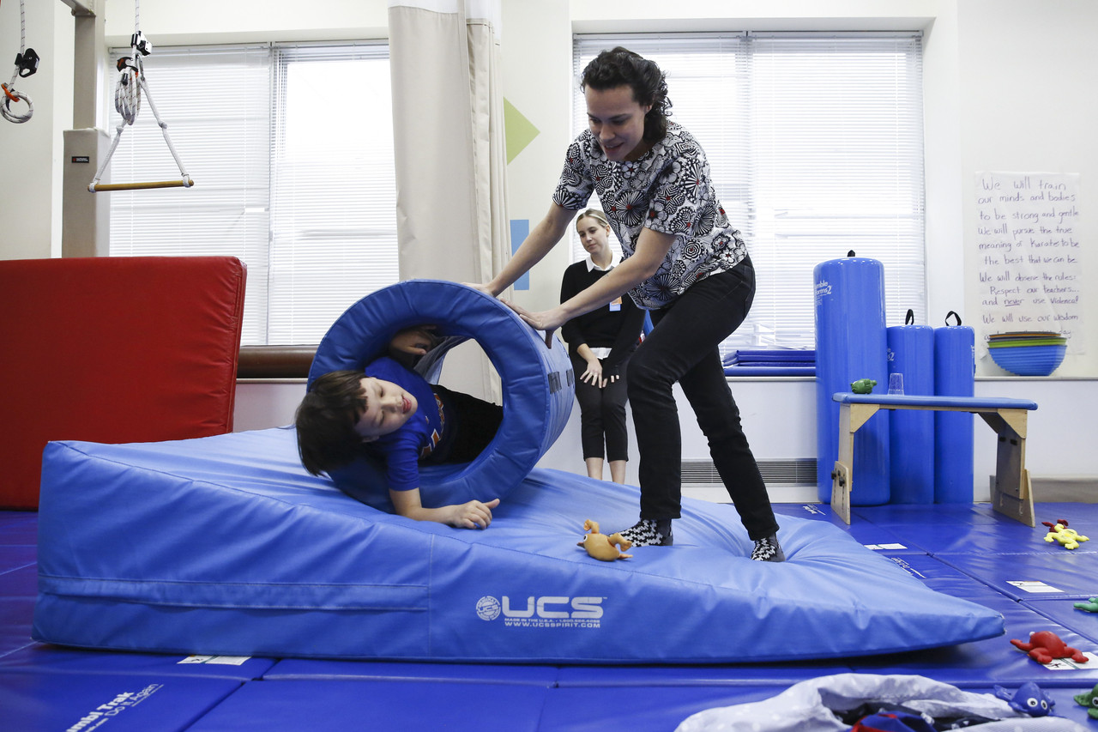
His mother helps Otis down a ramp in a barrel, an exercise that helps him with body awareness.
PHOTOS: CAITLIN OCHS FOR THE WALL STREET JOURNAL
The researchers are comparing a standard therapy for autism, applied behavioral analysis (ABA), with a lesser-used approach, sensory integration therapy (SIT), the therapy Otis is receiving.
Researchers say children with autism struggle to process and integrate sounds, sights and smells from everyday life. This can cause them to labor with common tasks at home and school. The researchers want to see if SIT develops some of these skills useful in daily life and helps the brain process and respond to information from the outside world.
For this study, about 180 children have been randomly placed into one of three groups: ABA, SIT or a control group, which is supposed to continue with whatever services they are already receiving. The children in the ABA and SIT groups come to Einstein three times a week for one-hour sessions over 10 to 12 weeks. They are between 6 and 9 1/2 years old and have varying levels of symptoms.
For SIT, occupational therapists use the whole body in a play-based approach. They might link the picky eating of a child with autism to oral motor difficulties and then work on activities like blowing on different kinds of toys. The theory is that by working on the underlying causes of problem behavior, you can also change the behavior.
ABA is a more traditional therapy in which a therapist focuses on the targeted behavior and rewards a child. Using this technique with a picky eater, the researcher would try over and over to get a child to eat a very small portion of the food he resists. If he eats it, he could receive a sticker or an M&M.
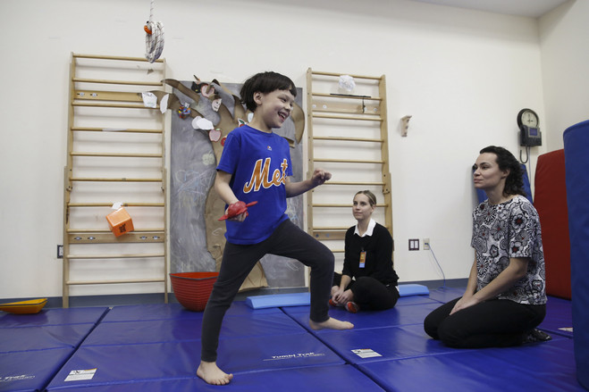
One of Otis’s goals is to be able to do five to six dance moves. PHOTO: CAITLIN OCHS FOR THE WALL STREET JOURNAL

“You’re working on a specific goal the entire way,” says Sophie Molholm, a professor in the pediatrics and neuroscience departments at Albert Einstein/Montefiore and director of the cognitive neurophysiology lab there.
The children also undergo neuropsychological testing to measure brain activity. They wear what looks like a swim cap with electrodes as they play various games.
Dr. Molholm says sensory integration therapy appeals to children because it feels like play. They get to roll around and jump on things to help them gain control of their bodies. Researchers encourage exercises to improve balance and core strength.
The researchers set five goals for each child with their parents. They want to see if one therapy is more effective depending on the severity of autism or the types of symptoms. They will compare progress on each child’s individual goals, as well as practical daily-living skills, such as brushing their teeth, and some behavioral measures.
Roseann Schaaf, a professor in the occupational-therapy department at Thomas Jefferson University in Philadelphia, is overseeing the study with Dr. Molholm.
The groundwork for the study came from a pilot study she published in the Journal of Autism and Developmental Disorders in 2014 in which 32 children diagnosed with autism were randomized to either a group receiving SIT and a control group. The intervention group received 30 sessions of therapy.
“For children with autism, it’s not usually one approach that fixes everything.”
—Donna Murray, vice president and head of clinical programs, Autism Speaks
They found the children in the sensory group showed a greater improvement in functional skills, socialization and individual goals.
Dr. Schaaf says the higher scores in socialization surprised her. She speculates that the therapy helped the children feel more comfortable in their bodies and how they navigated the world around them.
Donna Murray, vice president and head of clinical programs for Autism Speaks, a national nonprofit that funds autism research, says no one is looking to determine which single method is better.
“For children with autism, it’s not usually one approach that fixes everything,” she says.
For Otis, the five goals set by his mother included greeting the doorman, getting dressed in the morning with three prompts or fewer, being able to do five to six dance moves, walking 10 blocks without difficulty and trying three new foods.
The net-swing exercise helps Otis with body awareness, balance, posture and endurance, says Mr. Conly, his occupational therapist. After Mr. Conly works with Otis on the swing, he starts beating a drum and asks him to step to the beat of the drum. This is meant to help Otis’s coordination so he sequence dance moves, Mr. Conly later explains.
Otis next gets to roll down a ramp in a big barrel, crushing plastic cups along the way. “This really gives him a sense of whole-body awareness,” Mr. Conly says. Otis has difficulty understanding the boundaries of his body—like how close he is to another person—so pushing and pulling heavy things gives his body feedback on that.
Mr. Conly ends the session encouraging Otis to eat some half-frozen grapes to work on his goal of eating fruits and vegetables. Otis doesn’t like their squishy texture and spits out most of his bites.
“Even though we didn’t get him to the end result of eating the half-frozen grapes—just talking about it and it wasn’t a negative experience, I would view that as a success,” Mr. Conly says.
Otis is a high-functioning second-grader who started his therapy sessions this fall.
“He’s made a lot of progress,” says his mother.
She says he can run in a straight line now, which he couldn’t do before.
“Just physically, he’s stronger and able to do more of the physical tasks that I was doing for him,” she adds. “He’s just becoming much more confident athletically, which is great.”
Write to Sumathi Reddy at Sumathi.Reddy@wsj.com

